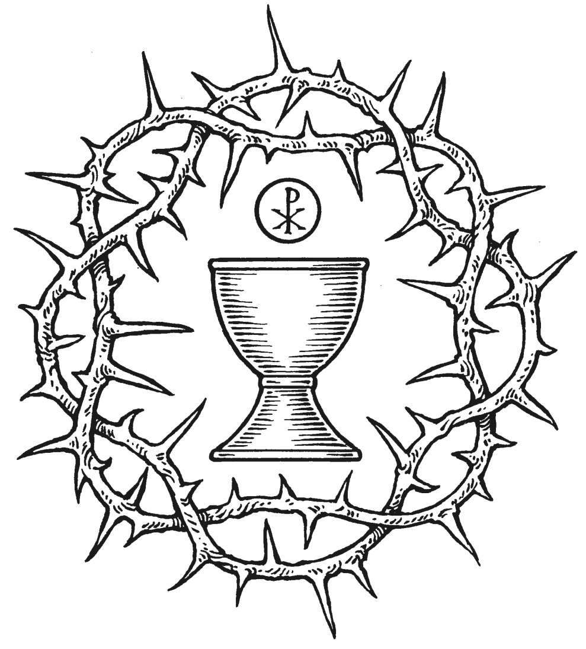
TRIDUUM
Christ Lutheran Church

CHRIST LUTHERANCHURCH | Lodi, California
WELCOME TO CHRIST!
We are happy you could join us. If we can assist you in any way with questions about our confession of faith, spiritual struggles, or any other need, please let us know. It is our prayer that the Gospel of Jesus Christ will strengthen and comfort you.
SERVICE NOTES FROM THE PASCAL TRIDUUM
The significance of Christ’s suffering, death, and resurrection has always been the central focus of Christian worship. Prior to the fourth century, Easter Day itself included all three emphases, but thereafter they were distributed over three days of special observance, which St. Augustine of Hippo called “the most holy triduum (“three days”) of the crucified, buried, and risen Lord.” These days have long been understood as the climax of the church’s year. We hope you notice the close connection between the three services of Maundy Thursday (Institution of the Lord’s Supper), Good Friday (Christ’s death), and Holy Saturday, known as the Vigil of Easter (Christ buried in the tomb). Each of these services connects, one into another. For this reason, all three services are included in this folder. This is also the reason that the service this evening, as well as tomorrow evening, does not include a blessing. That blessing will come at the end of the third service—Easter Vigil—which we will celebrate at Easter morning.

HOLY THURSDAY

As with Ash Wednesday, Holy Thursday, also known as Maundy Thursday, marks a unique place in the church calendar. Just as Ash Wednesday begins Lent, so Maundy Thursday marks the end of Lent and the beginning of the Three Holy Days of Christendom – the Triduum
The word Maundy comes from the Latin mandatum novum, the “new command” Jesus spoke in John 13:34, to “love one another as I have loved you.” The institution of the Lord’s Supper sets forth the depth of Jesus’ love and gives the Church power to live out his command. Maundy Thursday is a festival in which reconciliation is solemnly expressed and in which the congregation makes its transition from preparation for the celebration of the paschal mystery to the celebration itself.
The post-Communion action of stripping the altar has its roots in the early custom of preparing the church for Good Friday and Easter by means of thoroughly cleaning and washing the altar and chancel. After the post-Communion prayer, the altar, which represents the presence of Christ, is solemnly stripped of its vestments and appointments in memory of the abandonment of Jesus in Gethsemane. The liturgy then ends in silence. The congregation hears no final blessing – yet. Rather, the three services of the Triduum flow into one another as the congregation disperses in silence, to reassemble on Good Friday.
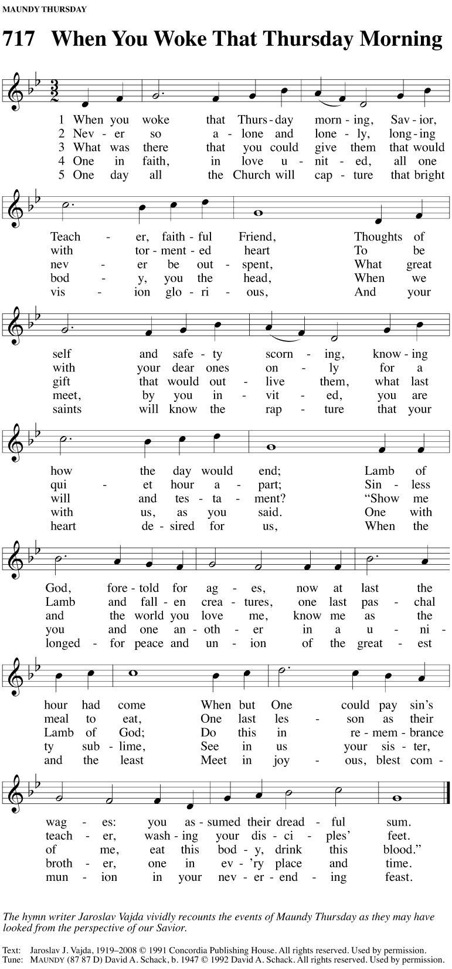
HYMN 717 When You Woke that Thursday Morning

INSTRUCTION FOR THE END OF LENT
M: In this Lenten season, we have heard our Lord’s call to intensify our struggle against sin, death, and the devil—all that keeps us from loving God and one another. This is the struggle to which we were committed at baptism; God’s forgiveness and the power of his Spirit to amend our lives continue with us because of his love for us in Jesus our Savior.
Within the family of the church, God never wearies of giving peace and new life. In the Absolution we receive forgiveness as from God himself. This absolution we should not doubt, but firmly believe that thereby our sins are forgiven before God in heaven, for it comes to us in the name and by the command of our Lord.
We who receive God‘s love in Jesus Christ are called to love one another, to be servants to one another as Jesus became our Servant.
In Holy Communion the members of Christ’s body participate most intimately in his love. We remember our Lord’s Last Supper with his disciples. Though for a time we are unable to gather we recall the blessings that we will share with all the faithful when our Lord returns.
CONFESSION AND ABSOLUTION
M: Our help is in the name of the Lord,
C: who made heaven and earth. Psalm 124:8
M: I said, I will confess my transgressions unto the Lord,
C: and you forgave the iniquity of my sin. Psalm 32:5
M: Let us confess our sins to God and ask for his forgiveness.
Silence for self-examination in light of God’s Word and His commands.
M: Almighty God, merciful Father,
C: I confess to you that I have not loved you with all my heart.
In what I have done and left undone,
I have pursued my ways instead of your ways.
I have not loved my brothers and sisters as myself.
For this I deserve your punishment both now and in eternity.
I am truly sorry for my sins.
I repent of them.
I beg for your mercy, O Lord.
M: Forgive us for the sake of Jesus Christ who suffered and died for us.
C: Cleanse me from my sins.
Release me from my guilt.
Grant me your Holy Spirit to amend my sinful life.
M: The almighty God has been merciful to us and has sent his Son to die for all. For his sake, God forgives our sins and calls us from darkness to his marvelous light.
Therefore, as a called servant of Christ and by his authority, I forgive you all your sins in the name of the Father and of the Son ✙ and of the Holy Spirit.
C: Amen.
EXHORTATION
M: Our Lord Jesus Christ has forgiven us and reconciled us to God and has promised us the power to forgive and love each other. Relying on his promise, therefore, be reconciled with one another.
C: Brothers and sisters, may the peace of Christ rule in our hearts, in our words, and in our actions.

PRAYER OF THE DAY
M: Let us pray.
O King of heaven, Servant of God, great is your name and worthy of honor. For your supreme sacrifice, we praise you, O Lord. For your holy Supper, we glorify you. For the gift of eternal life, we give you humble thanks. Send your Spirit, dear Savior, to help us in thankfulness to follow your example of humble service. Move us to have compassion on others and to seek ways to help them. Open our hearts and our lips to witness to your unconditional love. Be with us as you have promised.
C: Amen
FIRST LESSON Exodus 12:1-14
The people of Israel celebrate the first Passover in Egypt. Here is the Lamb of God, prefigured in the Passover and pointed to by St. John the Baptist. Here is the true blood of the Lamb painted no more on doorposts, but given for us to eat and to drink In the fulfillment of the Passover, only one is struck down—not Pharaoh’s firstborn, nor ours, but the only begotten Son of God.
²¹ Then Moses summoned all the elders of Israel and said to them, “Go, select an animal from the flock according to your families, and slaughter the Passover animal. ²² Take a cluster of hyssop, dip it in the blood that is in the basin, and brush the lintel and the two doorposts with some of the blood in the basin. None of you may go out the door of his house until morning. ²³ When the Lord passes through to strike Egypt and sees the blood on the lintel and the two doorposts, he will pass over the door and not let the destroyer enter your houses to strike you.
²⁴ “Keep this command permanently as a statute for you and your descendants. ²⁵ When you enter the land that the Lord will give you as he promised, you are to observe this ceremony. ²⁶ When your children ask you, ‘What does this ceremony mean to you?’ ²⁷ you are to reply, ‘It is the Passover sacrifice to the Lord, for he passed over the houses of the Israelites in Egypt when he struck the Egyptians and spared our homes.’” So the people knelt low and worshiped. ²⁸ Then the Israelites went and did this; they did just as the Lord had commanded Moses and Aaron.
²⁹ Now at midnight the Lord struck every firstborn male in the land of Egypt, from the firstborn of Pharaoh who sat on his throne to the firstborn of the prisoner who was in the dungeon, and every firstborn of the livestock. ³⁰ During the night Pharaoh got up, he along with all his officials and all the Egyptians, and there was a loud wailing throughout Egypt because there wasn’t a house without someone dead.
PSALM OF THE DAY Psalm 116
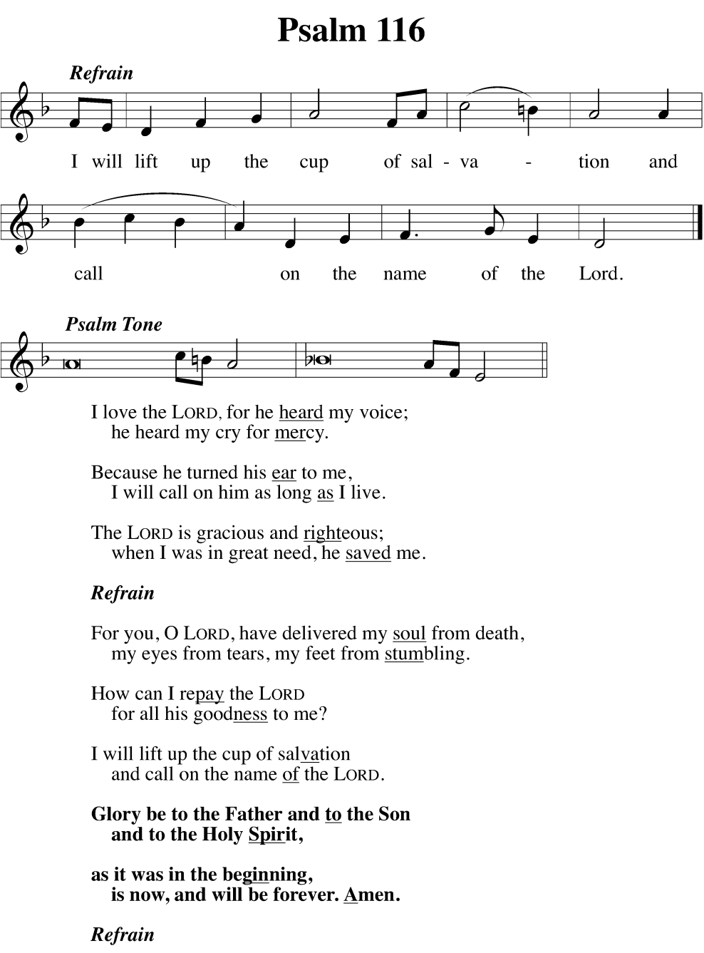
“All people are at some point “frightened to death.” Death’s grip is terrible because it is the result of our sin and separation from God. But this Psalm reminds us that God cares deeply about our mortality and has released us from its permanent bonds through the suffering, death, and resurrection of his Son.
SECOND LESSON 1 Corinthians 11:23-28
Paul passes on what he has received from Jesus himself.
²³ For I received from the Lord what I also passed on to you: On the night when he was betrayed, the Lord Jesus took bread, ²⁴ and when he had given thanks, broke it, and said,^{[a]} “This is my body, which is^{[b]} for you. Do this in remembrance of me.”
²⁵ In the same way also he took the cup, after supper, and said, “This cup is the new covenant in my blood. Do this, as often as you drink it, in remembrance of me.” ²⁶ For as often as you eat this bread and drink the cup, you proclaim the Lord’s death until he comes.
²⁷ So then, whoever eats the bread or drinks the cup of the Lord in an unworthy manner will be guilty of sin against the body^{[c]} and blood of the Lord. ²⁸ Let a person examine himself; in this way let him eat the bread and drink from the cup.

VERSE OF THE DAY 1 Corinthians 11:26
As often as you eat this bread and drink the cup, you proclaim the Lord’s death until he comes
Gospel John 13:1-15, 34
Jesus sets forth a “new command”: “Love one another.” This command, or mandate, is the source for the name of this day. But why don’t we celebrate a sacrament of footwashing? Footwashing was not merely a ritual with symbolic meaning, it was something that was done all the time. The signifigance of the event isn’t on what’s being done, but on who is doing it. The focus is on Jesus, his saving work, his love, his sacrifice. Look at the one who is washing.
13 Before the Passover Festival, Jesus knew that his hour had come to depart from this world to the Father. Having loved his own who were in the world, he loved them to the end.
² Now when it was time for supper, the devil had already put it into the heart of Judas, Simon Iscariot’s son,^{[a]} to betray him. ³ Jesus knew that the Father had given everything into his hands, that he had come from God, and that he was going back to God. ⁴ So he got up from supper, laid aside his outer clothing, took a towel, and tied it around himself. ⁵ Next, he poured water into a basin and began to wash his disciples’ feet and to dry them with the towel tied around him.
⁶ He came to Simon Peter, who asked him, “Lord, are you going to wash my feet?”
⁷ Jesus answered him, “What I’m doing you don’t realize now, but afterward you will understand.”
⁸ “You will never wash my feet,” Peter said.
Jesus replied, “If I don’t wash you, you have no part with me.”
⁹ Simon Peter said to him, “Lord, not only my feet, but also my hands and my head.”
¹⁰ “One who has bathed,” Jesus told him, “doesn’t need to wash anything except his feet, but he is completely clean. You are clean, but not all of you.” ¹¹ For he knew who would betray him. This is why he said, “Not all of you are clean.”
¹² When Jesus had washed their feet and put on his outer clothing, he reclined again and said to them, “Do you know what I have done for you? ¹³ You call me Teacher and Lord—and you are speaking rightly, since that is what I am. ¹⁴ So if I, your Lord and Teacher, have washed your feet, you also ought to wash one another’s feet. ¹⁵ For I have given you an example, that you also should do just as I have done for you.
³⁴ “I give you a new command: Love one another. Just as I have loved you, you are also to love one another.
HYMN OF THE DAY 313 Jesus Christ, Our Blessed Savior

SERMON TEXT Luke 22:47,48
⁴⁷ While he was still speaking, suddenly a mob came, and one of the Twelve named Judas was leading them. He came near Jesus to kiss him, ⁴⁸ but Jesus said to him, “Judas, are you betraying the Son of Man with a kiss?”
SERMON Now it’s Personal

OFFERING

THE GREAT LITANY
Prayer of Approach to God
M: O God the Father, Creator of heaven and earth,
C: Have mercy on us.
M: O God the Son, Redeemer of the world,
C: Have mercy on us.
M: O God the Holy Spirit, advocate and guide,
C: Have mercy on us.
M: Holy, blessed, and glorious Trinity, three persons in one God,
C: Have mercy on us.
Prayer for Deliverance
M: Remember not, Lord Christ, our offenses nor the offenses of our forebears. Spare us, good Lord; spare your people, whom you have redeemed with your precious blood.
C: Spare us, good Lord.
M: From all spiritual blindness; from pride, vainglory, and hypocrisy; from envy, hatred, and malice; and from all lack of charity,
C: Good Lord, deliver us.
M: From all deadly sin and from the deceits of the world, the flesh, and the devil,
C: Good Lord, deliver us.
M: From all false doctrine, heresy, and schism; from hardness of heart and contempt for your Word and your will,
C: Good Lord, deliver us.
M: From earthquake and tempest; from drought, fire, and flood; from civil strife and violence; from war and murder; and from dying suddenly and unprepared,
C: Good Lord, deliver us.
M: By the mystery of your holy incarnation; by your baptism, fasting, and temptation; and by your proclamation of the kingdom,
C: Good Lord, deliver us.
M: By your bloody sweat and bitter grief, by your cross and suffering, and by your precious death and burial,
C: Good Lord, deliver us.
M: By your mighty resurrection, by your glorious ascension, and by the coming of the Holy Spirit,
C: Good Lord, deliver us.
M: In our times of trouble, in our times of prosperity, in the hour of death, and on the day of judgment,
C: Good Lord, deliver us.
M: Receive our prayers, O Lord our God.
C: Hear us, good Lord.
Prayer for the Church
M: Govern and direct your holy Church, fill it with love and truth, and grant it that unity which is according to your will.
C: Hear us, good Lord.
M: Enlighten all ministers with true knowledge and understanding of your Word, that by their preaching and living they may declare it clearly and show its truth.
C: Hear us, good Lord.
M: Encourage and prosper your servants who spread the gospel in all the world, and send out laborers into the harvest.
C: Hear us, good Lord.
M: Bless and keep your people, that all may find and follow their true vocation and ministry.
C: Hear us, good Lord.
M: Give us hearts to love and revere you, that we may diligently live according to your commandments.
C: Hear us, good Lord.
M: To all your people, give grace to hear and receive your Word and to bring forth the fruits of the Spirit.
C: Hear us, good Lord.
M: Strengthen those who stand firm in the faith, encourage the fainthearted, raise up those who fall, and finally give us the victory.
C: Hear us, good Lord.
Prayer for Our Country
M: Rule the hearts of your servants, our president, our governor, and all others in authority, that they may do justice, love mercy, and walk in the ways of truth.
C: Hear us, good Lord.
M: Bless and defend all who strive for our safety and protection, and shield them in all dangers and adversities.
C: Hear us, good Lord.
M: Grant wisdom and insight to those who govern us and to judges and magistrates the grace to execute justice with mercy.
C: Hear us, good Lord.
Prayer for All People
M: To all nations grant unity, peace, and concord, and to all people give clothing, food, and shelter.
C: Hear us, good Lord.
M: Grant us abundant harvests, strength and skill to conserve the resources of the earth, and wisdom to use them well.
C: Hear us, good Lord.
M: Enlighten with your Spirit all who teach and all who learn.
C: Hear us, good Lord.
M: Come to the help of all who are in danger, necessity, and trouble; protect all who travel by land, air, or water; and show your pity on all prisoners and captives.
C: Hear us, good Lord.
M: Strengthen and preserve all women who are in childbirth and all young children, and comfort the elderly, the bereaved, and the lonely.
C: Hear us, good Lord.
M: Defend and provide for the widowed and the orphaned, the refugees and the homeless, the unemployed, and all who are desolate and oppressed.
C: Hear us, good Lord.
M: Heal those who are sick in body or mind, and give skill and compassion to all who care for them.
C: Hear us, good Lord.
M: Grant us true repentance, forgive our sins, and strengthen us by your Holy Spirit to amend our lives according to your Holy Word.
C: Hear us, good Lord.
Concluding Prayer
M: Son of God, we ask you to hear us.
C: Son of God, we ask you to hear us.
M: Lamb of God, you take away the sin of the world;
C: Have mercy on us.
M: Lamb of God, you take away the sin of the world;
C: Have mercy on us.
M: Lamb of God, you take away the sin of the world;
C: Grant us peace.
M: Lord, have mercy on us.
C: Christ, have mercy on us.
M: Lord, have mercy on us.
C: Amen.

LORD’S PRAYER
Our Father, who art in heaven, hallowed be thy name.
Thy kingdom come.
Thy will be done, on earth as it is in heaven.
Give us this day our daily bread.
and forgive us our trespasses,
as we forgive those who trespass against us.
And lead us not into temptation, but deliver us from evil.
For thine is the kingdom, and the power, and the glory,
forever and ever. Amen.
THE STRIPPING OF THE ALTAR
JESUS’ ARREST Matthew 26:50-56
PSALM 88
verses sung by the cantor, This psalm may contain a foreshadowing of Jesus’ arrest and imprisonment. As he awaited trial before the Sanhedrin, he may have been placed in a “holding cell,” known as “the pit.” Abandoned by all his friends and followers, with the darkness as his only companion, Jesus begins to enter the depth of his suffering. As the psalm is chanted, the altar is solemnly stripped in token of the Lord’s abandonment and in preparation for Good Friday.

Silent Prayer
The congregation may remain for prayer and meditation. When you are ready to leave, please do so in silence

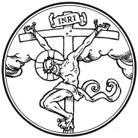
GOOD FRIDAY - Tenebrae

Good Friday is not a “funeral” for Jesus, but rather a celebration of the Lamb and his sacrifice. The bare altar, symbolic of Christ, is the focus. The Service of Darkness centers on a series of lessons, psalms, and liturgical texts that reflect on the Lord’s crucifixion and our repentance.
As the service progresses, seven lit candles are extinguished until only one remains. This candle is not extinguished but is removed from the chancel, leaving the church in darkness. This action is meant to symbolize the darkness that came upon the earth at the death of Christ. The service is closed by a loud noise, known as the strepitus, which foreshadows the rending of Jesus’ tomb on Easter. After the strepitus, the last candle, still burning, is returned to the chancel. It thus anticipates the light of the paschal candle, which will be lit at the Easter Vigil. As with both of the first two liturgies of the Triduum, this service ends without a benediction. The congregation is encouraged to leave quietly, and will reassemble for the final service of the Triduum, Easter Vigil, on Easter Sunday morning.

This service incorporates time for meditation and reflection. The service is celebrated simply and not hurried. In keeping with the solemn nature of this Holy Day, there is no prelude or other preservice music; minimal music is used only to support congregational singing
The Tenebrae candelabrum is lighted.
Please stand.
THE GOSPEL John 19:17-30
M: A reading from the Gospel of St. John:
¹⁷ Carrying his own cross, he went out to the place of the Skull (which in Aramaic is called Golgotha). ¹⁸ There they crucified him, and with him two others—one on each side and Jesus in the middle.
¹⁹ Pilate had a notice prepared and fastened to the cross. It read: jesus of nazareth, the king of the jews. ²⁰ Many of the Jews read this sign, for the place where Jesus was crucified was near the city, and the sign was written in Aramaic, Latin and Greek. ²¹ The chief priests of the Jews protested to Pilate, “Do not write ‘The King of the Jews,’ but that this man claimed to be king of the Jews.”
²² Pilate answered, “What I have written, I have written.”
²³ When the soldiers crucified Jesus, they took his clothes, dividing them into four shares, one for each of them, with the undergarment remaining. This garment was seamless, woven in one piece from top to bottom.
²⁴ “Let’s not tear it,” they said to one another. “Let’s decide by lot who will get it.”
This happened that the scripture might be fulfilled that said,
“They divided my clothes among them
and cast lots for my garment.”^{[a]}
So this is what the soldiers did.
²⁵ Near the cross of Jesus stood his mother, his mother’s sister, Mary the wife of Clopas, and Mary Magdalene. ²⁶ When Jesus saw his mother there, and the disciple whom he loved standing nearby, he said to her, “Woman,^{[b]} here is your son,” ²⁷ and to the disciple, “Here is your mother.” From that time on, this disciple took her into his home.
²⁸ Later, knowing that everything had now been finished, and so that Scripture would be fulfilled, Jesus said, “I am thirsty.” ²⁹ A jar of wine vinegar was there, so they soaked a sponge in it, put the sponge on a stalk of the hyssop plant, and lifted it to Jesus’ lips. ³⁰ When he had received the drink, Jesus said, “It is finished.” With that, he bowed his head and gave up his spirit.
Please be seated.
PSALM 2
This Psalm is one of the most frequently quoted Old Testament passages in the New Testament. It makes the point quite clearly that Jesus is Lord, and that He is in charge. In a time of uncertainty and chaos, this is a truth to hold on to. Jesus is Lord of all, and Lord of the nations, even when it doesn’t seem that way.
This Psalm stands out in its emphasis on judgment. It promises justice and threatens those who oppose the kingdom of God. The Son is the one who will bring judgment on the wicked. In a world full of injustice, where too often the evil seems to get away with evil deeds, this Psalm is comforting. Justice will come.
A Conversation between Father and Son.
M: The kings of the earth take their stand and the rulers gather together against the LORD and against his Anointed One.
M: Why do the nations conspire
C: and the peoples plot in vain?
M: The kings of the earth take their stand and the rulers gather together
C: against the LORD and against his Anointed One.
M: “Let us break their chains,” they say,
C: “And throw off their fetters.”
M: The One enthroned in heaven laughs;
C: The Lord scoffs at them.
M: Then he rebukes them in his anger and terrifies them in his wrath, saying,
C: “I have installed my King on Zion, my holy hill.”
M: I will proclaim the decree of the LORD:
C: He said to me, “You are my Son; today I have become your Father.
M: Ask of me, and I will make the nations your inheritance,
C: The ends of the earth your possession.
M: You will rule them with an iron scepter;
C: You will dash them to pieces like pottery.”
M: Therefore, you kings, be wise;
C: Be warned, you rulers of the earth.
M: Serve the LORD with fear
C: and rejoice with trembling.
M: Kiss the Son, lest he be angry and you be destroyed in your way, for his wrath can flare up in a moment.
C: Blessed are all who take refuge in him.
M: The kings of the earth take their stand and the rulers gather together against the LORD and against his Anointed One.
The first candle is extinguished.
Silence for meditation
Psalm 22
God foretold that the Savior would be scorned and despised
M: They divide my garments among them and cast lots for my clothing.
M: My God, my God, why have You forsaken Me?
C: Why are You so far from saving Me—so far from the words of My groaning?
M: My God, I cry out by day, but You do not answer—
C: by night and am not silent.
M: Yet You are enthroned as the Holy One.
C: You are the Praise of Israel!
M: In You our fathers put their trust;
C: They trusted and You delivered them.
M: They cried to You and were saved.
C: In You they trusted and were not disappointed.
M: But I am a worm and not a man,
C: scorned by men and despised by the people.
M: All they who see Me mock Me.
C: They hurl insults shaking their heads:
M: “He trusted in the LORD. Let the LORD rescue him!
C: Let him deliver him, since he delights in him.”
M: Yet you brought me out of the womb.
C: You made me trust in you even at my mother’s breast.
M: From birth I was cast upon you;
C: From My mother’s womb you have been my God.
M: Do not be far from Me,
C: for trouble is near and there is no one to help.
M: Many bulls surround Me;
C: strong bulls of [Bay-shan]Bashan encircle Me.
M: Roaring lions, tearing their prey,
C: open their mouths wide against Me.
M: I am poured out like water, and all My bones are out of joint.
C: My heart has turned to wax; it has melted away within Me.
M: My strength is dried up like a potsherd, and My tongue sticks to the roof of my mouth.
C: You lay Me in the dust of death.
M: Dogs have surrounded Me—a band of evil men has encircled Me.
C: They have pierced My hands and My feet.
M: I can count all My bones.
C: People stare and gloat over Me.
M: They divide My garments among them
C: and cast lots for My clothing.
M: But You, O LORD, be not far off.
C: O my Strength, come quickly to help Me.
M: Deliver My life from the sword—
C: My precious life from the power of the dogs,
M: Rescue me from the mouth of the lions.
C: Save Me from the horns of the wild oxen.
M: They divide my garments among them and cast lots for my clothing.
The second candle is extinguished.
Silence for meditation

Psalm 27
M: False witnesses rise up against me, breathing out violence.
M: The Lord is my light and my salvation–whom shall I fear?
C: The Lord is the stronghold of my life–of whom shall I be afraid?
M: When evil men advance against me to devour my flesh,
C: When my enemies and my foes attack me, they will stumble and fall.
M: Though an army besiege me, my heart will not fear;
C: though war break out against me, even then will I be confident.
M: On thing I ask of the Lord, this is what I seek:
C: That I may dwell in the house of the Lord all the days of my life, to gaze upon the beauty of the Lord and to seek him in his temple.
M: For in the day of trouble he will keep me safe in his dwelling;
C: He will hide me in the shelter of his tabernacle and set me high upon a rock.
M: Then my head will be exalted above the enemies who surround me;
C: At his tabernacle will I sacrifice with shouts of joy; I will sing and make music to the Lord.
M: Hear my voice when I call, O LORD;
C: Be merciful to me and answer me.
M: My hearts says of you, “Seek his face!”
C: Your face, LORD, I will seek.
M: Do not hide your face from me, do not turn your servant away in anger; you have been my helper.
C: Do not reject me or forsake me, O God my Savior.
M: Though my father and mother forsake me,
C: The LORD will receive me.
M: Teach me your way, O LORD;
C: Lead me in a straight path because of my oppressors.
M: Do not turn me over to the desire of my foes.
C: For false witnesses rise up against me, breathing out violence.
M: I am still confident of this:
C: I will see the goodness of the LORD in the land of the living.
M: Wait for the Lord;
C: Be strong and take heart and wait for the LORD.
M: False witnesses rise up against me, breathing out violence.
The third candle is extinguished.
Silence for meditation
SEEK THE LORD - Quaerite Dominum
The text is from Isaiah 55:6-11, and focuses on the grace and mercy of God as he comes to us through his Word. It is a fitting addition to our Good Friday service, as we realize how we have sinned against the Lord and once again heed the Lord’s call to repent
Seek the LORD while he may be found; call upon him while he is near. Let the wicked forsake his way and the evil man his thoughts. Let him turn to the LORD, and he will have mercy on him, and to our God, for he will freely pardon. “For my thoughts are not your thoughts, neither are your ways my ways,” declares the LORD. “As the heavens are higher than the earth, so are my ways higher than your ways and my thoughts than your thoughts. As the rain and the snow come down from heaven and do not return to it without watering the earth and making it bud and flourish, so that it yields seed for the sower and bread for the eater, so is my word that goes out from my mouth: It will not return to me empty; but will accomplish what I desire and achieve the purpose for which I sent it.”
The fourth candle is extinguished

Hymn 122 Sing, My Tongue, the Glorious Battle

LESSON Lamentations 1:1-5
M: A reading from the Lamentations of Jeremiah the prophet:
How deserted lies the city, once so full of people!
How like a widow is she, who once was great among the nations!
She who was queen among the provinces has now become a slave.
Bitterly she weeps at night, tears are upon her cheeks.
Among all her lovers there is none to comfort her.
All her friends have betrayed her; they have become her enemies.
After affliction and harsh labor, Judah has gone into exile.
She dwells among the nations; she finds no resting place.
All who pursue her have overtaken her in the midst of her distress.
The roads to Zion mourn, for no one comes to her appointed feasts.
All her gateways are desolate, her priests groan,
her maidens grieve, and she is in bitter anguish.
Her foes have become her masters; her enemies are at ease.
The LORD has brought her grief because of her many sins.
Her children have gone into exile, captive before the foe.
M: Jerusalem, Jerusalem, return to the Lord your God!
The minister directs this call to repentance to the congregation under his care. “Jerusalem” is often used to refer to the Church, the people of God who have been destroyed by sin.
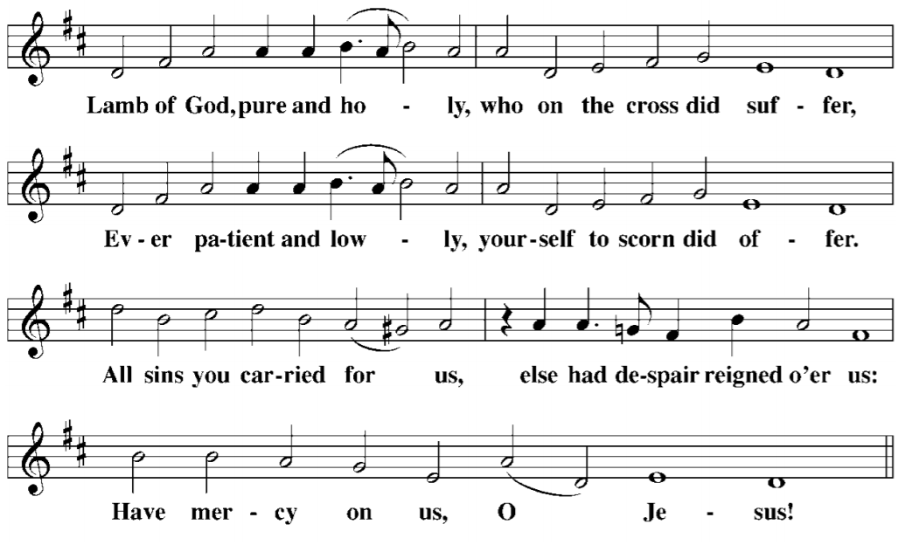
LESSON Lamentations 1:6-9
M: A reading from the Lamentations of Jeremiah the prophet:
All the splendor has departed from the Daughter of Zion.
Her princes are like deer that find no pasture;
in weakness they have fled before the pursuer.
In the days of her affliction and wandering, Jerusalem remembers all the treasures that were hers in days of old.
When her people fell into enemy hands there was no one to help her.
Her enemies looked at her and laughed at her destruction.
Jerusalem has sinned greatly and so has become unclean.
All who honored her despise her nakedness;
she herself groans and turns away.
Her filthiness clung to her skirts; she did not consider her future.
Her fall was astounding; there was none to comfort her.
“Look, O LORD, on my affliction, for the enemy has triumphed.”
M: Jerusalem, Jerusalem, return to the Lord your God!
LESSON Lamentations 1:10-14

M: A reading from the Lamentations of Jeremiah the prophet:
The enemy laid hands on all her treasures;
she saw pagan nations enter her sanctuary—
those you had forbidden to enter your assembly.
All her people groan as they search for bread;
they barter their treasures for food to keep themselves alive.
“Look, O LORD, and consider, for I am despised.”
“Is it nothing to you, all you who pass by? Look around and see.
Is any suffering like my suffering that was inflicted on me,
that the Lord brought on me in the day of his fierce anger?
“From on high he sent fire, sent it down into my bones.
He spread a net for my feet and turned me back.
He made me desolate, faint all the day long.
“My sins have been bound into a yoke; by his hands they were woven together.
They have come upon my neck and the Lord has sapped my strength.
He has handed me over to those I cannot withstand.”
M: Jerusalem, Jerusalem, return to the Lord your God!
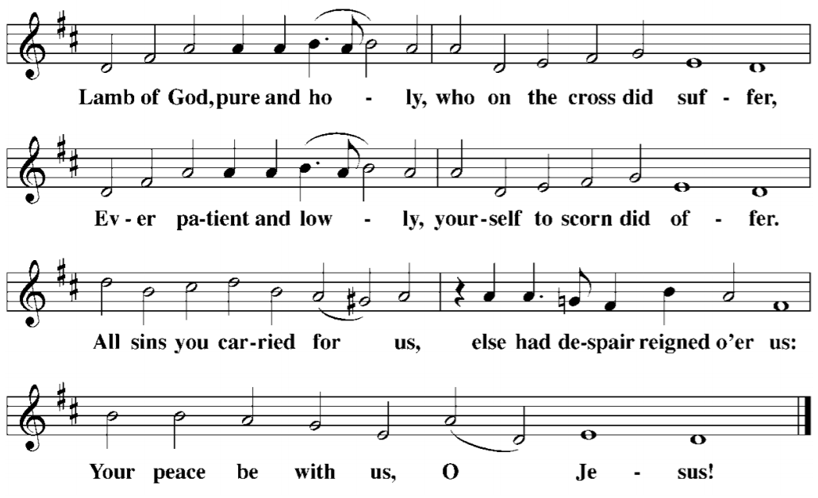
Three times we hear the prophet weep for the sins of Jerusalem, entreating her to turn again to her God. And three times the congregation looks to the Lamb of God, and cries out, "Have mercy on us."
The fifth candle is extinguished.
Silence for meditation.

Hymn 137 Oh, Darkest Woe
M: Christ became obedient for us unto death, even death on a cross. Therefore God has exalted him to the highest place and given him the name that is above every name.
LORD’S PRAYER
Our Father, who art in heaven, hallowed be thy name, thy kingdom come, thy will be done on earth as it is in heaven. Give us this day our daily bread; and forgive us our trespasses, as we forgive those who trespass against us; and lead us not into temptation, but deliver us from evil. For thine is the kingdom and the power and the glory forever and ever. Amen.

PSALM 51
This penitential Psalm of David serves as a final reminder of what this day means: We come before God with nothing, admitting that we have nothing of worthiness to offer him. Rather, we pray that, through his Son, he may have mercy on us.
M: Have mercy on me, O God,
according to your unfailing love;
according to your great compassion
blot out my transgressions.
Wash away all my iniquity
and cleanse me from my sin.

For I know my transgressions,
and my sin is always before me.
Against you, you only, have I sinned
and done what is evil in your sight,
so that you are proved right when you speak
and justified when you judge.
Surely I was sinful at birth,
sinful from the time my mother conceived me.
Surely you desire truth in the inner parts;
you teach me wisdom in the inmost place.

Cleanse me with hyssop, and I will be clean;
wash me, and I will be whiter than snow.
Let me hear joy and gladness;
let the bones you have crushed rejoice.
Hide your face from my sins
and blot out all my iniquity.

Create in me a pure heart, O God,
and renew a steadfast spirit within me.
Do not cast me from your presence
or take your Holy Spirit from me.
Restore to me the joy of your salvation
and grant me a willing spirit, to sustain me.

Then I will teach transgressors your ways,
and sinners will turn back to you.
Save me from bloodguilt, O God,
the God who saves me,
and my tongue will sing of your righteousness.
O Lord, open my lips,
and my mouth will declare your praise.
You do not delight in sacrifice, or I would bring it;
you do not take pleasure in burnt offerings.
The sacrifices of God are a broken spirit;
a broken and contrite heart, O God,
you will not despise.

In your good pleasure make Zion prosper;
build up the walls of Jerusalem.
Then there will be righteous sacrifices,
whole burnt offerings to delight you;
then bulls will be offered on your altar.
The sixth candle is extinguished.
The seventh candle is carried from the chancel.

PRAYER OF THE DAY
M: Almighty God, graciously behold this your family for whom our Lord Jesus Christ was willing to be betrayed, to be given into the hands of sinners, and to suffer death on the cross; who now lives and reigns with you and the Holy Spirit, one God, now and forever. Amen.
Silence for meditation
The seventh candle is extinguished, and the church is left in darkness. After a period of silence, a loud noise representing the rending of Christ’s tomb is heard and the candle is returned.

CLOSING ANTHEM 434 Lord, Let at Last Your Angels Come

Lord, let at last your angels come; To Abram’s bosom bear me home
That I may die unfearing. And in its narrow chamber keep
My body safe in peaceful sleep Until your reappearing.
And then from death awaken me That my own eyes with joy may see,
O Son of God, your glorious face, My Savior and my Fount of grace.
Lord Jesus Christ, My prayer attend, my prayer attend,
And I will praise you without end.
The minister exits. The congregation may remain for prayer and meditation before dispersing quietly.
If you wish to give an offering visit our website, mail or drop off at church.

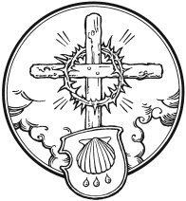
EASTER VIGIL

The Paschal Candle is a special candle used at every service during the Easter season and at baptisms and funerals year-round. The Paschal Candle—symbolizes the resurrection victory over the darkness of sin and death. It emphasizes the presence of the resurrected Christ and the link between baptism and the resurrection.
The name Paschal comes from the Greek, pascha. Before the time of Christ, this word was used for Passover; after Christ, Christians took to using the word when referring to the Festival of the Resurrection. Throughout the fifty days of Easter, the Paschal Candle traditionally stands near or in front of the altar as a symbol of resurrection. It is lighted for each service and is traditionally extinguished after the reading of the Gospel on Ascension. The Paschal Candle is of substantial size so its important symbolism speaks clearly. Even the stand in which it sits is of great size.

EASTER VIGIL
To "keep a vigil" is to stay awake during the time usually spent asleep, especially to keep watch or to pray. Let us keep watch as our Savior sleeps. The congregation assembles in the church in darkness and silence
The Service of Light - CW p. 54

PRAYER
M: On this most holy night, in which our Lord Jesus Christ passed over from death to life, we are gathered here in vigil and prayer. This is the Passover of the Lord in which, by hearing his Word and remembering his sacraments, we share in his victory over death.
C: Amen.

EASTER PROCLAMATION 245 Sing a New Song to the Lord

M: The Lord be with you.
C: And also with you.
M: Lift up your hearts.
C: We lift them up to the Lord.
M: Let us give thanks to the Lord our God.
C: It is right to give him thanks and praise.

M: It is truly good and right that we should at all times and in all places, with all our hearts and minds and voices, praise you, O Lord, Holy Father, almighty and everlasting God, and your one and only Son, Jesus Christ.
C: For he is the true Paschal Lamb, who offered himself for the sin of the world, who has cleansed us by the shedding of his precious blood.
M: This is the night when you brought our fathers, the children of Israel, out of bondage in Egypt and led them through the Red Sea on dry ground.
C: This is the night when all who believe in Christ are delivered from bondage to sin and are restored to life and immortality.
M: This is the night when Christ, the Life, arose from the dead. The seal of the grave is broken and the morning of the new creation breaks forth out of night. Oh, how wonderful and beyond all telling is your mercy toward us, O God, that to redeem a slave you gave your Son. How holy is this night when all wickedness is put to flight and sin is washed away. How holy is this night when innocence is restored to the fallen and joy is given to those downcast. How blessed is this night when man is reconciled to God in Christ.
C: Holy Father, accept now the evening sacrifices of our thanksgiving and praise. Let Christ, the true Light and Morning Star, shine in our hearts, he who gives light to all creation, who lives and reigns with you and the Holy Spirit, one God, now and forever. Amen.

II. SERVICE OF LESSONS
Traditionally four Old Testament Lessons are read. The first reading reminds us of the perfect existence that will be restored to us in heaven. The other readings tell of God’s great acts of deliverance in history, each prefiguring God’s greatest act of deliverance in the resurrection of Jesus Christ from the dead. A period of silence for meditation and prayer follows the first three readings.

M: On this most holy night, our Savior, Christ the Lord, broke the power of death and by his resurrection brought life and salvation to all creation. Let us praise the Lord, for he truly keeps his word. The sun of righteousness has dawned on those sitting in darkness and in the shadow of death.

FIRST LESSON Genesis 1:1-2:3
God created the world by his Word out of water. By the Word incarnate – crucified and risen – the world is recreated and made very good having been washed in Baptism.
M: Let us pray.
Almighty God, you most wonderfully created human nature and yet more wonderfully redeemed it. By your mercy renew us in the image of him who came to share our humanity, your Son, Jesus Christ, our Lord.
C: Amen.
Silence for meditation follows the Lesson.

SECOND LESSON Genesis 7:1-5, 11-18; 8:6-18; 9:8-13
By water the wicked world was destroyed and the godly saved. By water our wicked flesh is destroyed and we are saved.
M: Let us pray.
O Lord, whose wrath burned against the evil of humanity, you kill and bring again to life according to your own purpose; you brought the flood on a wicked and perverse generation and yet saved faithful Noah and his family. Gather your elect into your Church and so complete your work of mercy, that the ends of the earth may know your salvation; through Jesus Christ, our Lord.
C: Amen.
Silence for meditation follows the Lesson.
Psalm 46 (CWS page 46)
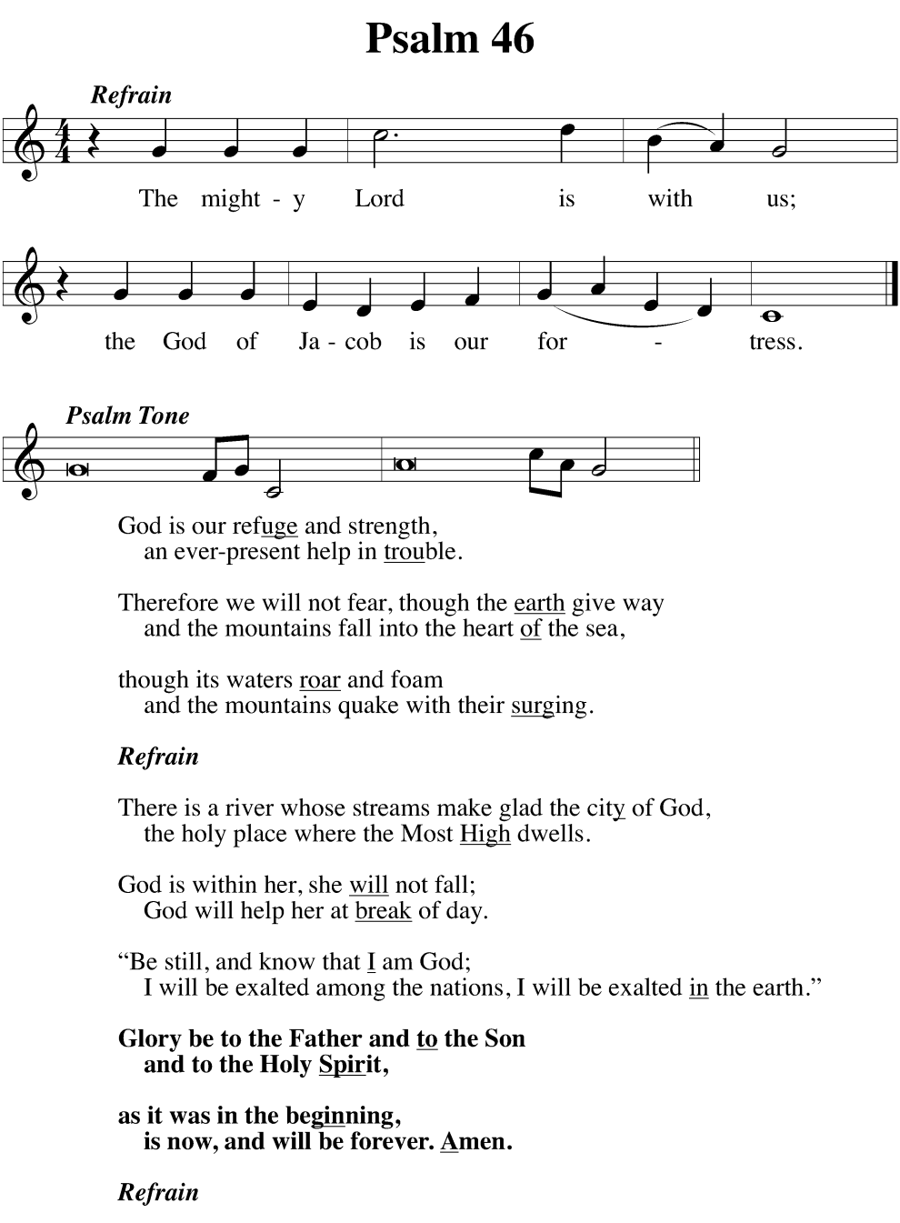

THIRD LESSON Genesis 22:1-18
Abraham’s sacrifice foreshadowed the one made God. Here we see our type of our Savior who carried our cross, shouldered our sins, and gave up his life for us all.
M: Let us pray.
O God, you promised to faithful Abraham that he would be the father of many nations, and through the Sacrament of Holy Baptism, you increase your chosen people throughout the world. Give to your Church a living trust in all your promises, through Jesus Christ our Lord.
C: Amen.

FOURTH LESSON Exodus 14:10-15:1
A Passover lamb, a fiery pillar, walls of water, death and life. This was all too real for God’s People. It all very real for us as the Lamb of God, the Light of the World brings us through the waters of Baptism into eternal life.
M: Let us pray.
O God, you once delivered your people Israel from slavery under Pharaoh and led them safely through the Red Sea. By this you gave us a picture of our Baptism. Lead us always to rejoice in your baptismal promise that we may live in its grace and declare to all people your desire to make them children of Abraham; through Jesus Christ, our Lord.
C: Amen.
Silence for meditation follows the Lesson.

FIFTH LESSON Isaiah 55:1-11
This water is free. This gift is for you. Don’t labor endlessly trying to earn what has been freely given by grace. That’s faith, and such faith bears fruit.
M: Let us pray.
Almighty God, you created and sustain all things by the power of your Word. You send forth your Spirit to renew your creation. Give your saving water of life to all who thirst, that they may bear much fruit in your glorious kingdom, through Jesus Christ our Lord.
C: Amen.

III: SERVICE OF BAPTISM
In ancient times adult catechumens, who underwent a one to three year catechesis, were baptized in this Vigil. The baptisms would occur during the Service of Holy Baptism. Those being baptized wore a white alb, much like pastor wears, symbolic of the white robe of righteousness.

M: On this holiest of days, the whole Church of our Lord Jesus Christ recalls his death and burial, rejoicing in the gospel of his glorious resurrection from the dead. Holy Baptism is the precious means of grace by which our Father in heaven connects us with Christ in his life, death, and resurrection. The apostle Paul says: “Don’t you know that all of us who were baptized into Christ Jesus were baptized into his death? We were therefore buried with him through Baptism into death in order that, just as Christ was raised from the dead through the glory of the Father, we too may live a new life. If we have been united with him in his death, we will certainly also be united with him in his resurrection. For we know that our old self was crucified with him so that the body of sin might be done away with, that we should no longer be slaves to sin—because anyone who has died has been freed from sin. Now if we died with Christ, we believe that we will also live with him. For we know that since Christ was raised from the dead, he cannot die again; death no longer has mastery over him. The death he died, he died to sin once for all; but the life he lives, he lives to God. In the same way, count yourselves dead to sin but alive to God in Christ Jesus.” (Romans 6:3-11, NIV)

HYMN 299 All Who Believe and Are Baptized

REAFFIRMATION OF BAPTISM
M: In Holy Baptism God takes away our sins and gives new life in Christ, our Lord. We solemnly renounce the devil and all his works and all his ways; we confess the gift of faith in God the Father, Son, and Holy Spirit. I ask you: Do you reject the devil along with all his lies and empty promises?
C: Yes, and I ask God to help me.
M: Do you believe in God, the Father Almighty?
C: Yes, I believe in God, the Father Almighty, maker of heaven and earth.
M: Do you believe in Jesus Christ, his only Son?
C: Yes, I believe in Jesus Christ, his only Son, our Lord, who was conceived by the Holy Spirit, born of the virgin Mary, suffered under Pontius Pilate, was crucified, died and was buried. He descended into hell. The third day he rose again from the dead. He ascended into heaven and is seated at the right hand of God the Father Almighty. From there he will come to judge the living and the dead.
M: Do believe in the Holy Spirit?
C: Yes, I believe in the Holy Spirit, the holy Christian Church, the communion of saints, the forgiveness of sins, the resurrection of the body, and the life everlasting. Amen.
M: Do you intend to continue in this faith, to be diligent in the use of Word and sacrament, and in faith and action remain true to God—Father, Son, and Holy Spirit—as long as you live?
C: Yes, and I ask God to help me.
M: Almighty God, the Father of our Lord Jesus Christ, who has given you the new birth of water and of the Spirit and has forgiven you all your sins, strengthen you with his grace to life everlasting.
C: Amen.

Stand

Service of the Holy Supper
The altar candles and other candles in the church are now lit from the Paschal Candle. The lights of the church are fully lit and the minister proclaims:

M: ALLELUIA! CHRIST IS RISEN!
C: HE IS RISEN INDEED! ALLELUIA!

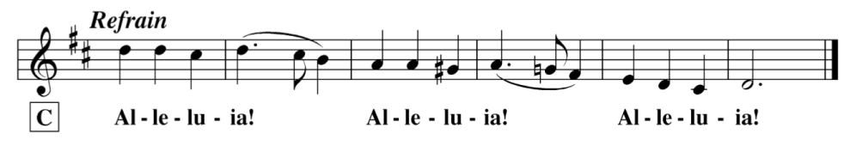
C: Refrain
M: For as in Adam all die, so in Christ all will be made alive. This is the day the Lord has made; Let us rejoice and be glad in it.
C: Refrain

GOSPEL Matthew 28:1-10
After the Sabbath, as the first day of the week was dawning, Mary Magdalene and the other Mary went to view the tomb. ² There was a violent earthquake, because an angel of the Lord descended from heaven and approached the tomb. He rolled back the stone and was sitting on it. ³ His appearance was like lightning, and his clothing was as white as snow. ⁴ The guards were so shaken by fear of him that they became like dead men.
⁵ The angel told the women, “Don’t be afraid, because I know you are looking for Jesus who was crucified. ⁶ He is not here. For he has risen, just as he said. Come and see the place where he lay. ⁷ Then go quickly and tell his disciples, ‘He has risen from the dead and indeed he is going ahead of you to Galilee; you will see him there.’ Listen, I have told you.”
⁸ So, departing quickly from the tomb with fear and great joy, they ran to tell his disciples the news. ⁹ Just then^{[a]} Jesus met them and said, “Greetings!” They came up, took hold of his feet, and worshiped him. ¹⁰ Then Jesus told them, “Do not be afraid. Go and tell my brothers to leave for Galilee, and they will see me there.”
M: The Gospel of the Lord!
PRAYER OF THE DAY
M: O God, who made this most holy night to shine with the glory of the resurrection of our Lord, preserve in all your people the Spirit of adoption which you have given, that they may serve you in faith and joy, through Jesus Christ, your Son, our Lord, who lives and reigns with you and the Holy Spirit, one God, now and forever.
C: Amen.

LORD’S PRAYER
C: Our Father in heaven, hallowed be your name, your kingdom come, your will be done on earth as in heaven. Give us today our daily bread. Forgive us our sins, as we forgive those who sin against us. Lead us not into temptation, but deliver us from evil. For the kingdom, the power, and the glory are yours now and forever. Amen.

M: Dear worshippers, as we gather to commemorate our Lord’s establishing of the New Testament Passover Meal—Holy Communion—as the visible seal of His pledge of forgiveness through His sacrificial blood, let us review the basic questions we studied in our confirmation instruction, explained simply by Dr. Martin Luther:
M: What is the Sacrament of the Altar?
C: It is the true body and blood of our Lord Jesus Christ, under the bread and wine, instituted by Christ for us Christians to eat and to drink.
M: What is the divine blessing or benefit that we receive from eating and drinking the body and blood of our Lord Jesus Christ under the bread and wine?
C: That blessing is shown us by these words: “Given” and “Poured out for you for the forgiveness of sins.” Through these words we receive forgiveness of sins, life, and salvation in this sacrament. For where there is forgiveness of sins, there is also life and salvation!
M: How can simply eating and drinking these elements do such great things as giving us those priceless blessings of forgiveness, life in God, and salvation?
C: It is certainly not the eating and drinking that does such things, but the words: “Given” and “Poured out for you for the forgiveness of sins.” These words are the main thing in this sacrament, along with the eating and drinking. And whoever believes these words has what they plainly say: the forgiveness of sins!
M: Who receives this Sacrament in a worthy manner to enjoy such priceless blessings? Is there something we need to do to make ourselves worthy and prepared?
C: Fasting and other outward preparations may serve a good purpose, but they are properly prepared who believe these words: “Given” and “Poured out for you for the forgiveness of sins.” But whoever does not believe these words or doubts them is not prepared because the words “for you” require nothing but hearts that believe!
PRAYER
M: Lord God, on the day before He suffered, Your Son, in His unfailing mercy and love, graciously instituted for us His holy Supper. Although we cannot now receive in our mouths His true body and blood, still we beg You to stir up our minds and hearts to a salutary remembrance of His benefits. Grant that by faith we may spiritually partake of Him as we recall the Words of His new and eternal Testament. For He promised us: “This is My body, which is given for you” and “this cup is the New Testament in My blood, which is shed for you, for the forgiveness of sins.” Grant us ever to rejoice in how Your Son once offered Himself upon the altar of the cross in our place—a Ransom pure, holy, and undefiled. Fill us now with His blood-bought forgiveness and pour every heavenly benediction and grace upon everyone who devoutly remembers this day His holy sacrifice. Gather us together from the ends of the earth to celebrate with all the faithful the marriage feast of the Lamb in His Kingdom which has no end. Amen.

BLESSING
M: The almighty and merciful Lord, the Father, the + Son, and the Holy Spirit, bless and keep us.
C: Amen.

Closing Hymn 162 He Is Arisen! Glorious Word

The Great Litany is named not because of its “great” length but because of its all-encompassing content. The word “litany” comes from the Latin “litania,” meaning "prayer" or “supplication.” The Great Litany was in use in Asia and in Rome at a very early date, as early as the 4th or 5th century. Tonight, we continue the tradition of saying the Great Litany on Maundy Thursday, following the command of our Lord to “love one another.” One of the greatest forms of love Christians can show is praying for others. The prayer begins with a Prayer of Approach to God. As sinners who approach God, we ask our Lord to spare us any punishment for our sins in the Prayer for Deliverance.

